Final Report

Name: Charles Taggart
Course / Cohort: FSDI 110 / CH 65
Assignment: 110 Final Report
GitHub Repository Link:

Evidence of Functionality
Frontend/UI
Backend/Logic:

GET – list of coupons
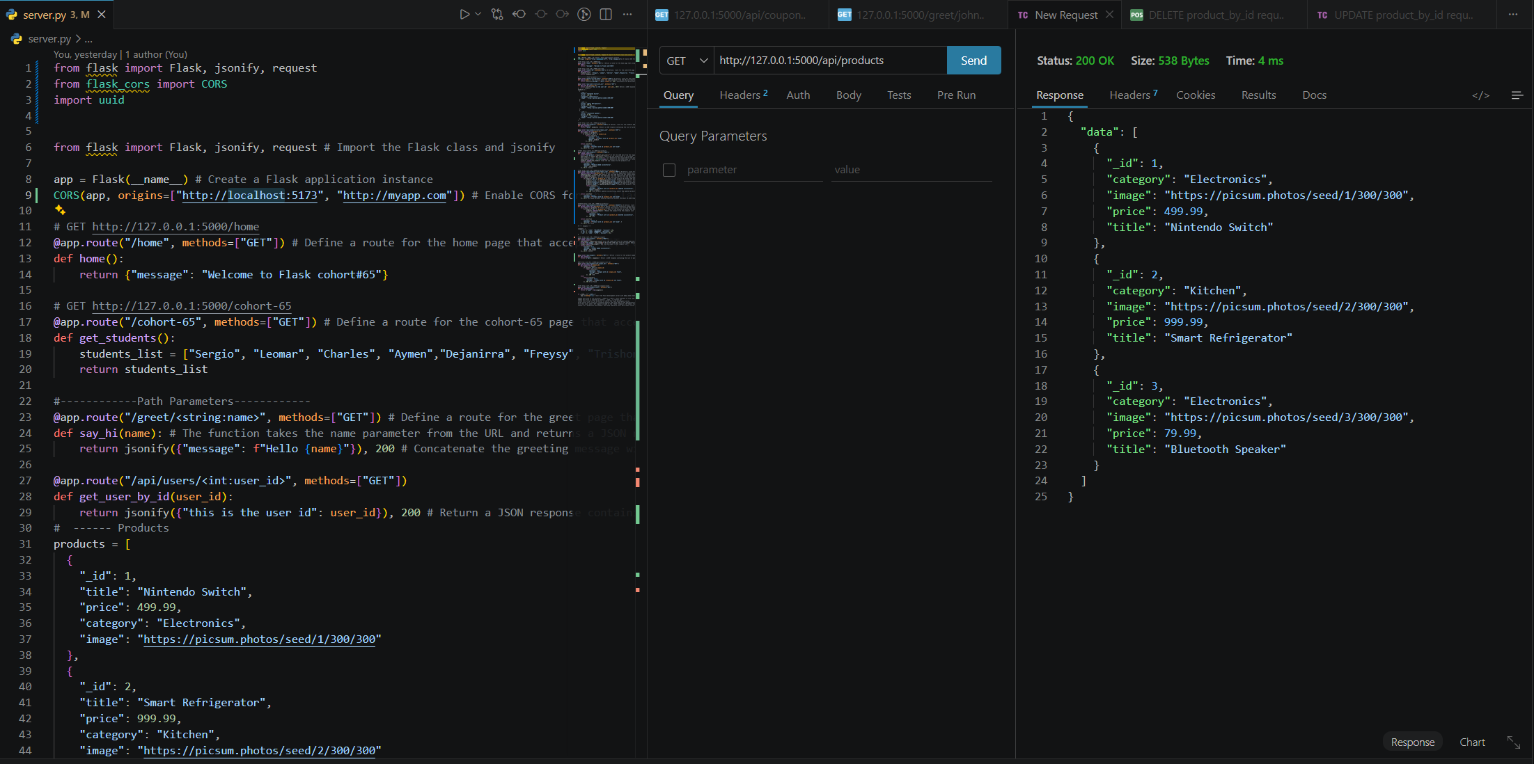
GET – coupons count
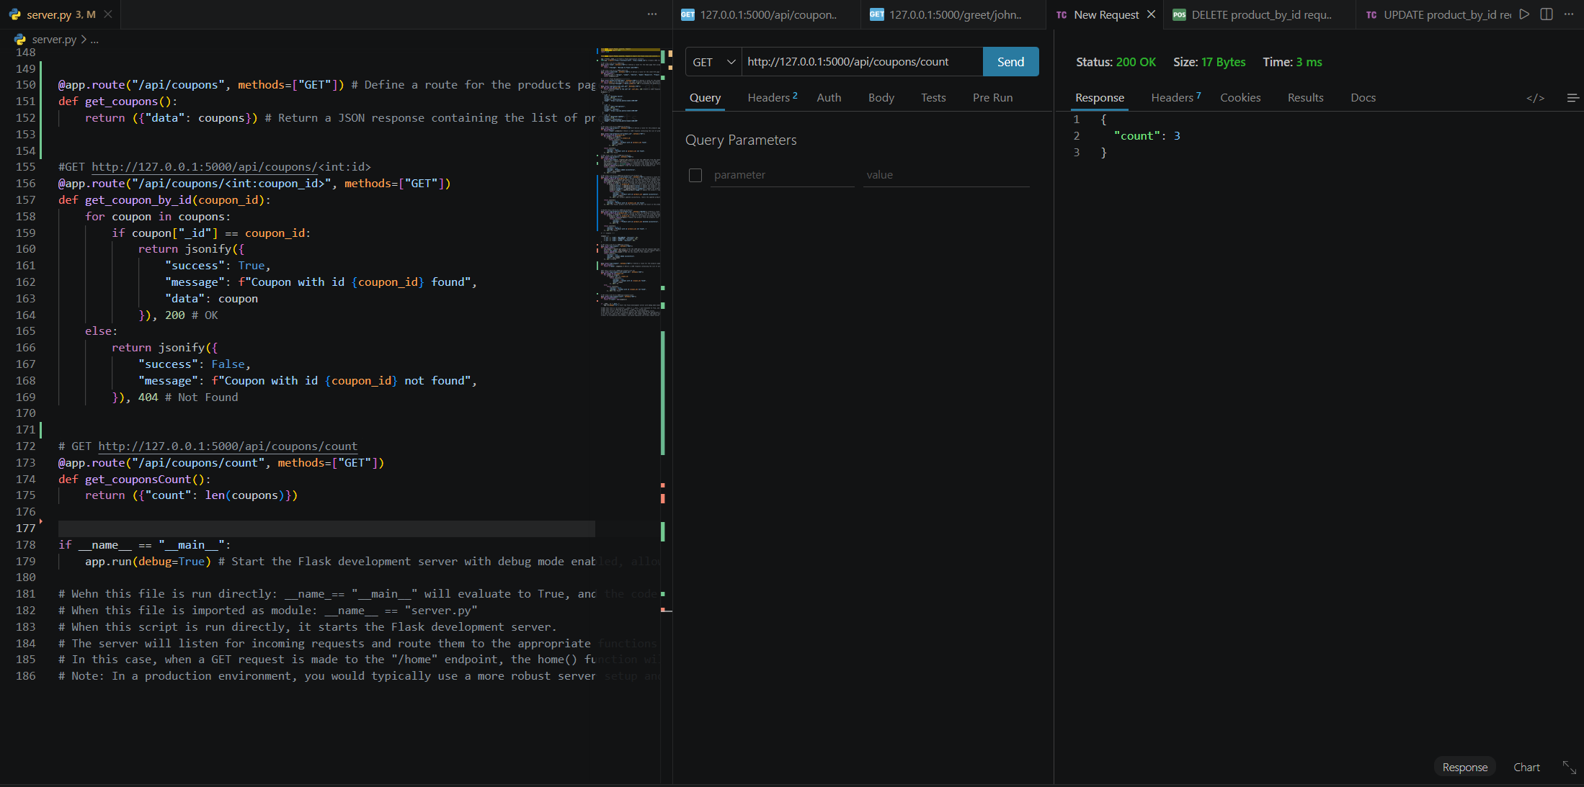
POST – add new coupon
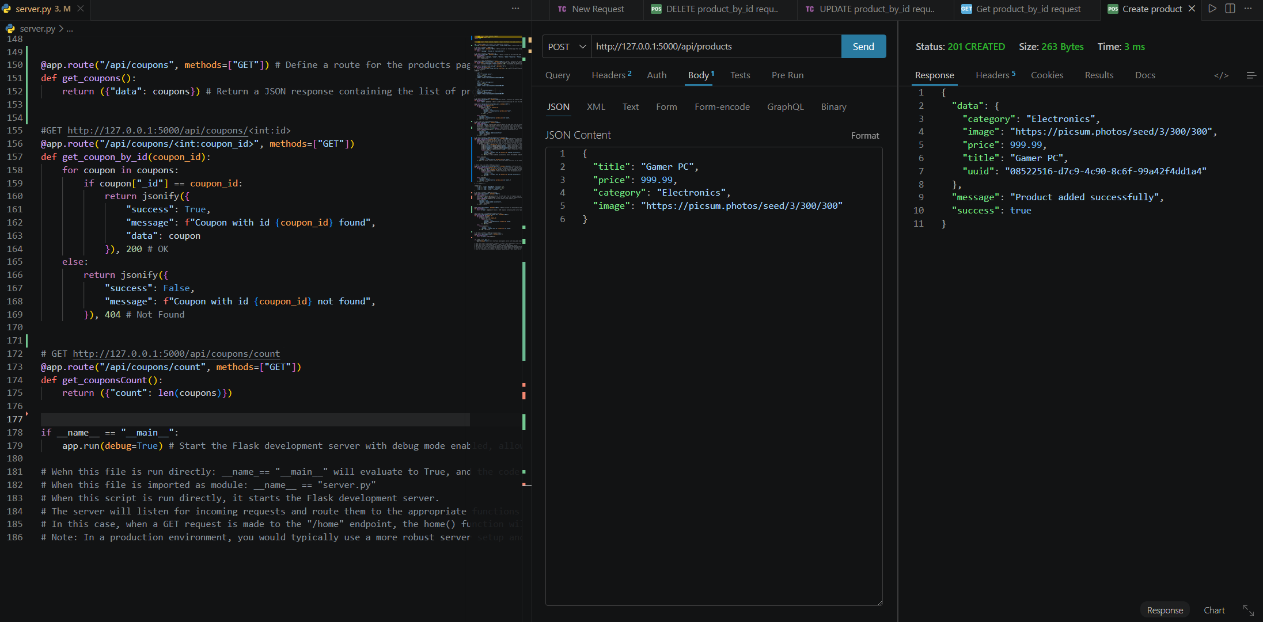
GET – Coupon by id
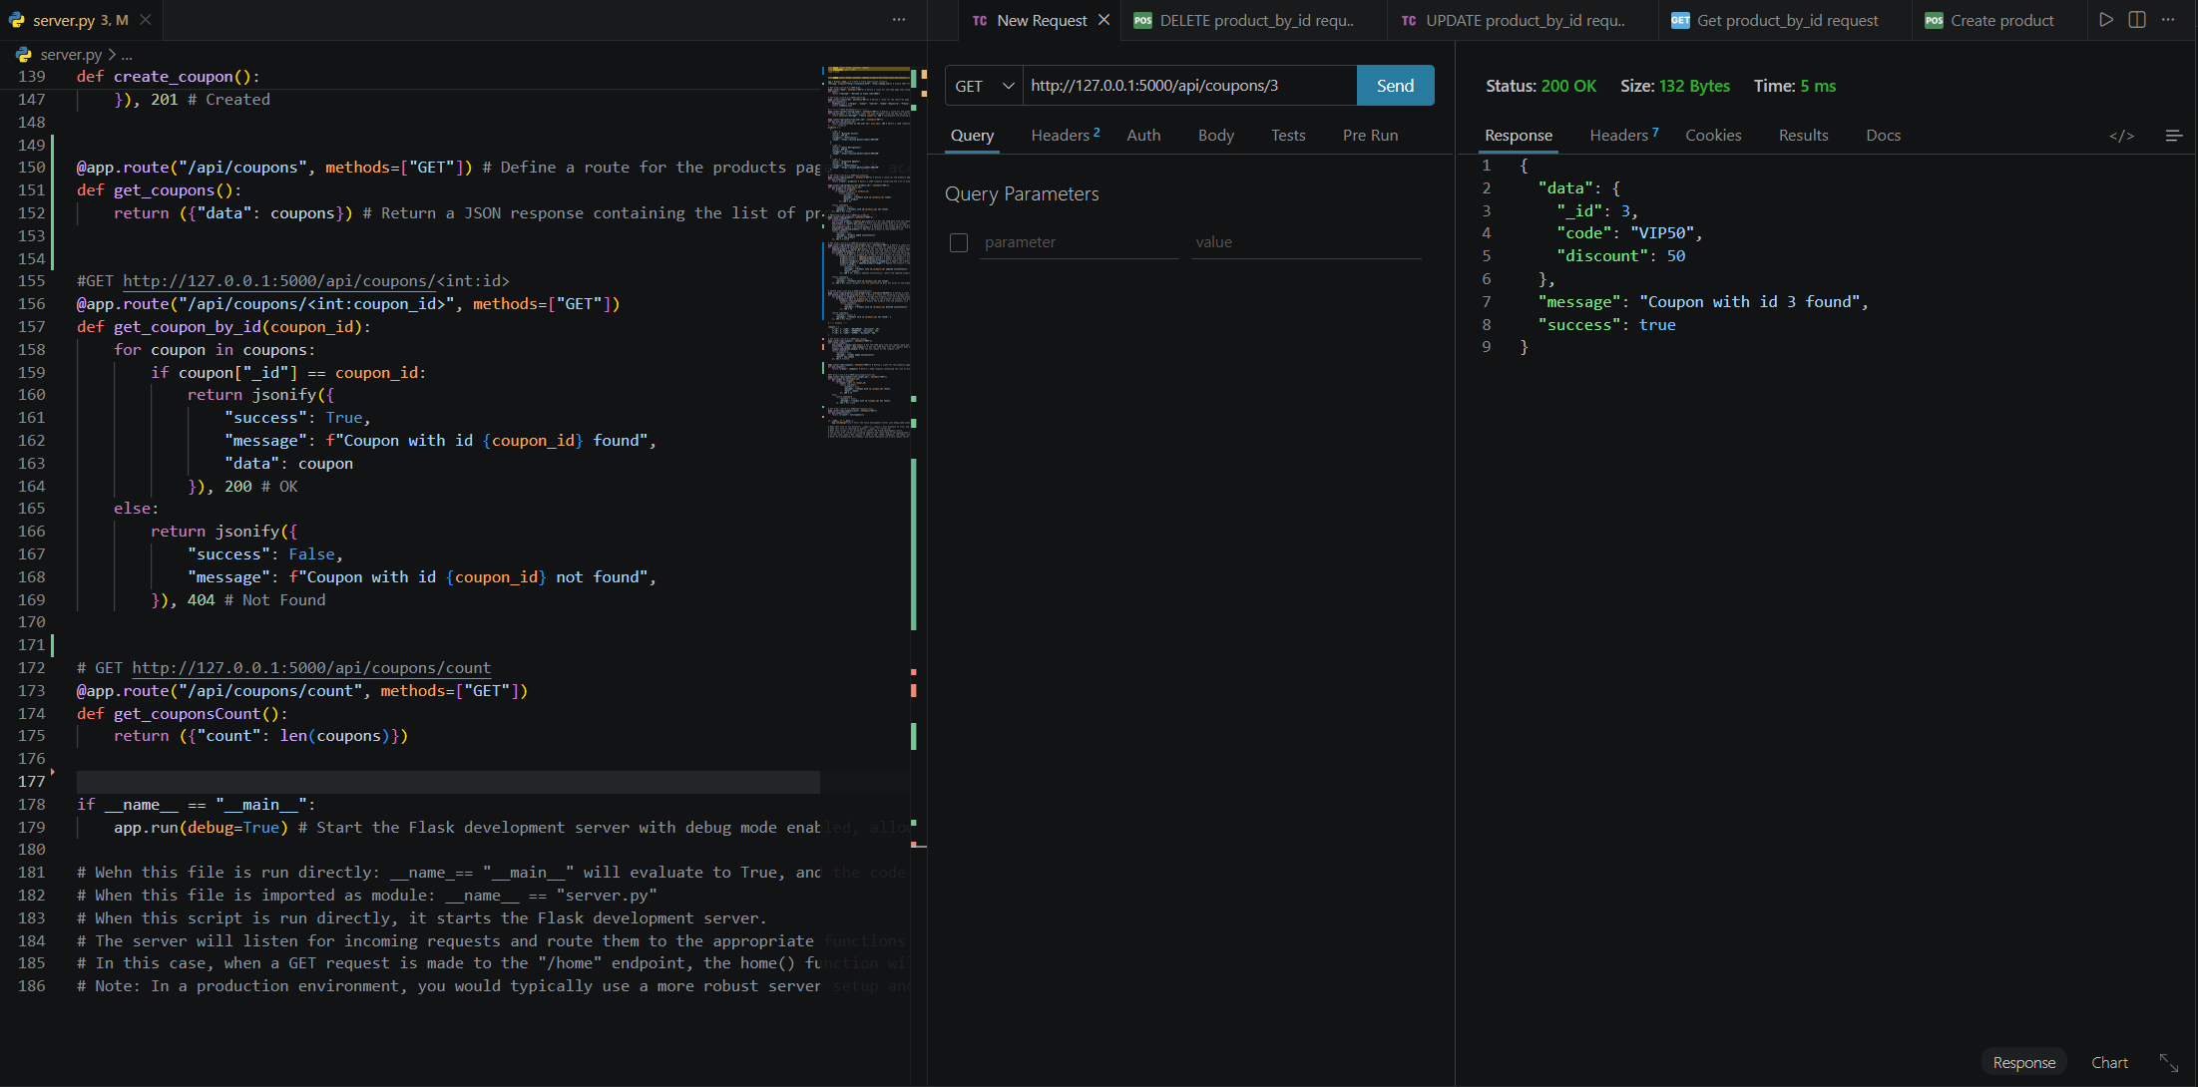
PUT – update coupon by id
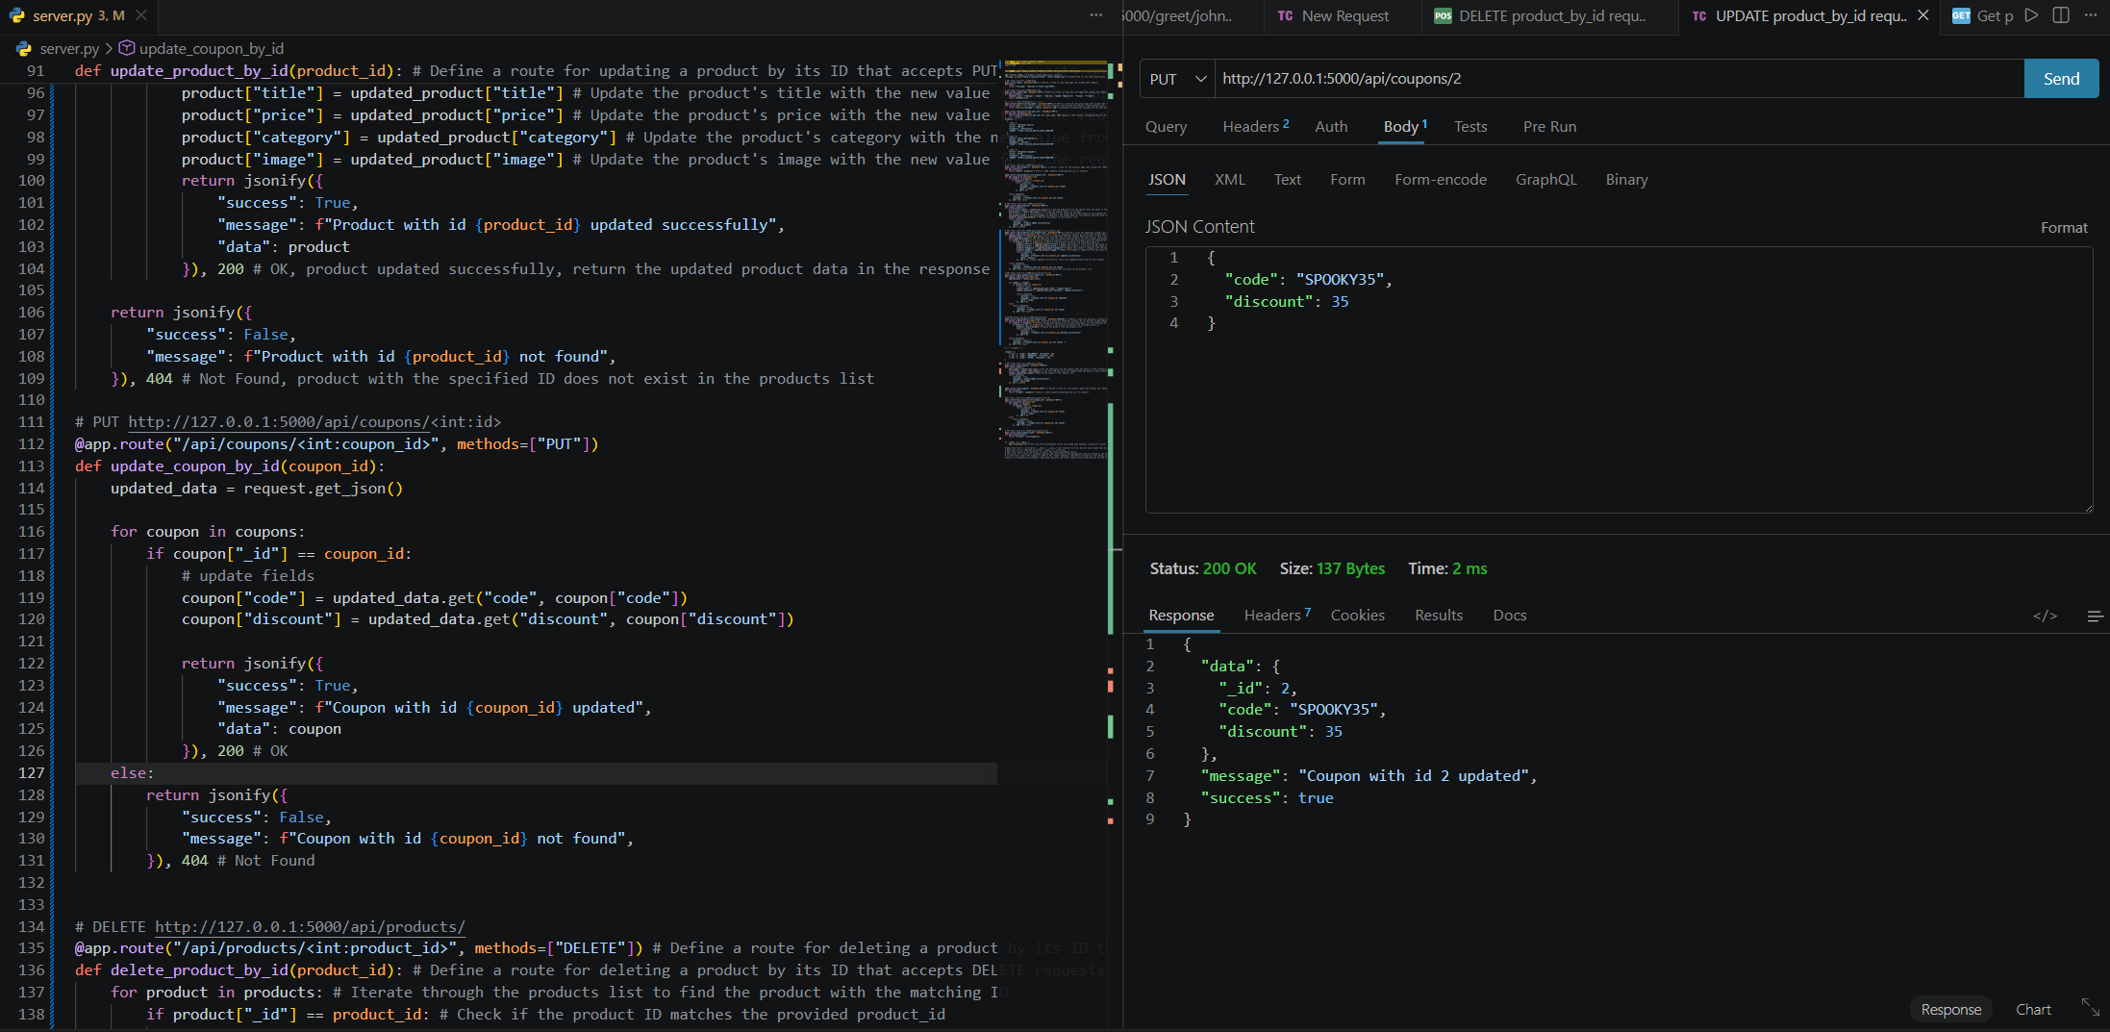
DELETE – coupon by id
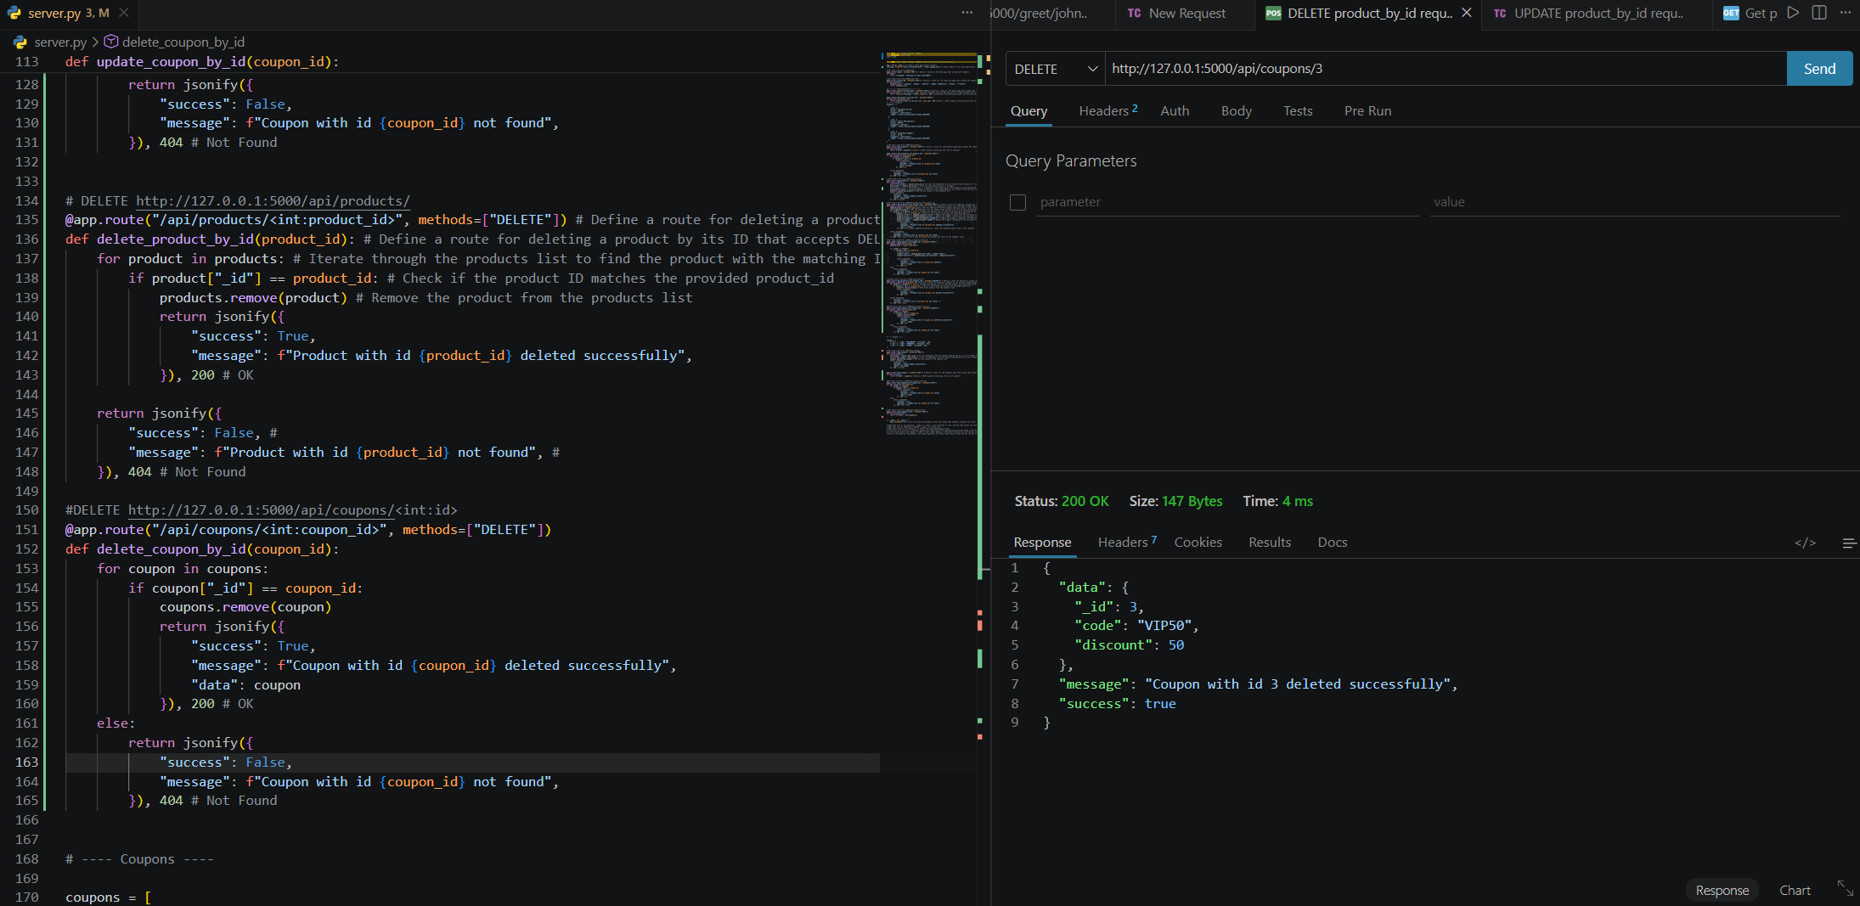
Retrospective
1.Which part of the project was the most difficult or challenging for you, and why?
This project was difficult because of the amount of attention to detail required in each block of code. I kept missing little details that needed to be updated, but I think with practice and more familiarity with the process, those errors should disappear.
2. What did you enjoy the most or learn the most from while working on this project, and why? This project was great for seeing how things can be updated in the background and seeing the changes taking place. I would like to work more closely with these processes to get more comfortable with them.

AI Disclosure (Required) – Highlight the one that applies
- I did not use AI
- I used AI for help
- AI generated parts of my code (if it’s the case, provide an explanation of the code in your own words).

